**BÁO CÁO BÀI THỰC HÀNH SỐ 5**

**Họ và tên:** Đặng Kim Ngân

**Mã số sinh viên:** 20225751

**Mã lớp:** 744520

1. **New written code**
2. **Swing components:** Tạo thư mục GUIProject đặt toàn bộ mã trong package hust.soict.hedspi.swing.
   1. **AWTAccumulator:** Tạo AWTAccumulator tạo GUI để nhập vào số và tính tổng các số đã nhập.

* 1. **SwingAccumulator:** Tạo lớp SwingAccumulator với chức năng tương tự AWTAccumulator

* 1. **So sánh các thành phần Swing và AWT:**
* Lập trình với AWT và Swing khá giống nhau (bao gồm các thành phần/container, xử lý sự kiện). Tuy nhiên, có một số khác biệt cần lưu ý:

• Container cấp cao nhất trong Swing và AWT.

• Tên lớp của các thành phần trong AWT và tên lớp tương ứng trong Swing.

1. **Organizing Swing components with Layout Managers**

* Sử dụng Jpanel như secondary-level container để tổ chức lại components.

1. **Create a graphical user interface for AIMS with Swing**

* Create View Store using Swing
* Create View Cart using JavaFX
* Create Update Store using JavaFX
  1. **Create the StoreScreen class**

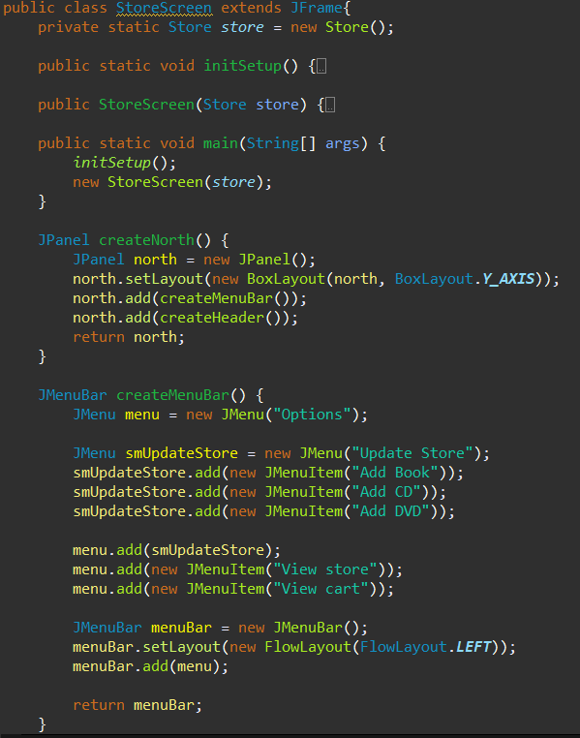

* 1. **Create MediaStore class**

1. **JavaFX API**
   1. **Create class PainterController**

* 1. **Create class Painter**

1. **Setting up the View Cart Screen with ScreenBuilder**

* Tạo cart.fxml trong hust.soict.hedspi.aims.screen.view

1. **Integrating JavaFX into Swing application – The JFXPanel class**

* Create CartScreen class

1. **View the items in cart – JavaFX’s data-driven UI**

* Create CartScreenController class

* Kết quả:

1. **Updating buttons based on selected item in TableView – ChangeListener**

1. **Deleting a media**

1. **Filter items in cart – FilteredList**

1. **Complete the Aims GUI application**
   1. **Complete CartScreen**

* Add method placeOrder in Cart:

* Kết nối StoreScreen với CartScreen

* 1. **Update StoreScreen**
     1. **Create AddDigitalVideoDiscToStoreScreen class:**

* + 1. **Create AddBookToStoreScreen class:**

* + 1. **Create AddCompactDiscToStoreScreen class**

* + 1. **Create AddTrackScreen class**

1. **Check all the previous source codes to catch/handle/delegate runtime exceptions**

* Throw Exception cho method addMedia() trong Cart.java và testCart.java

* Catch Exception trong MediaStore.java và Aims.java

1. **Create a class which inherits from Exception**
   1. **Create Player Exception class**

* 1. **Raise PlayerException in method play()**

* 1. **Update play()** in **CompactDisc**

1. **Update Aims class**
2. **Modify the equals() method of Media class**

1. **UML Diagram**
2. **Usecase Diagram**

1. **Class Diagram**

1. **Exception Hierachical**

